Data Science

Dashboard using Python

By Archit Vashist

Roll No-101917119

Batch-3CSE5

Dataset used – FIFA dataset

Documentation

About the dataset

The FIFA dataset contains information about the various players that are present in the video game FIFA 19. The important features present are->

1. Name
2. Age
3. Club of the Player
4. Nationality
5. Wage
6. Value
7. Overall (Rating between 0 and 100 depicted how good a player is)
8. Potential (Rating between 0 and 100 depicted how good a player can be.)

And other various ratings (out of hundred) about the players such as ShotPower, Passing stats, Shooting etc.

Screenshots of the dashboard

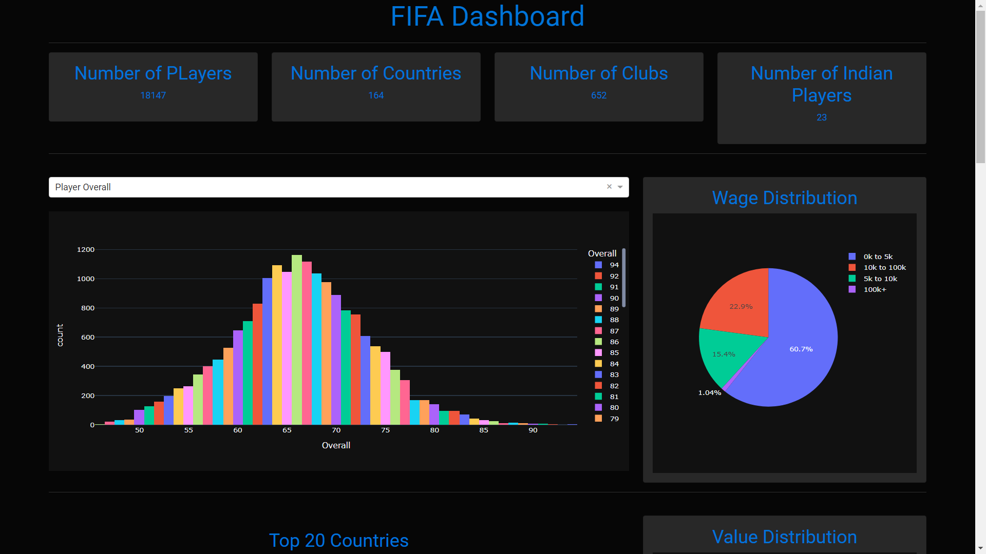

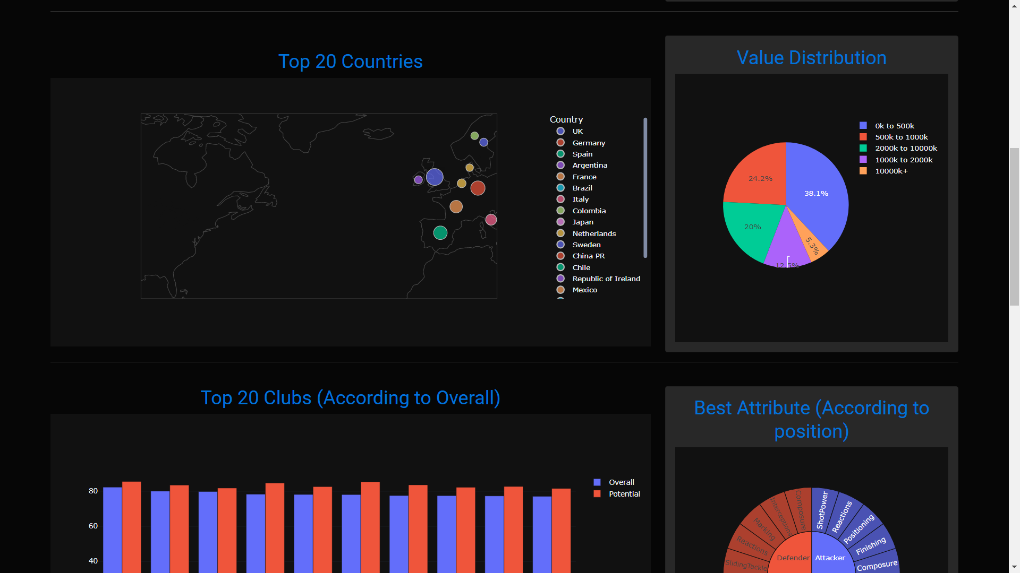

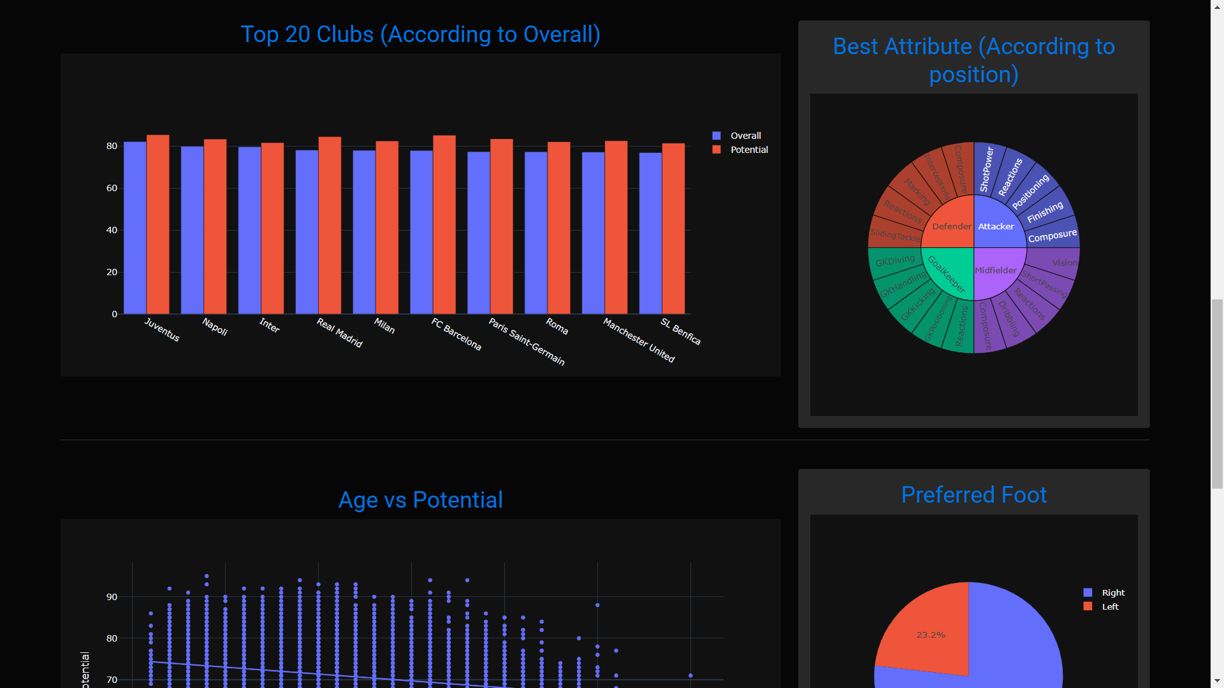

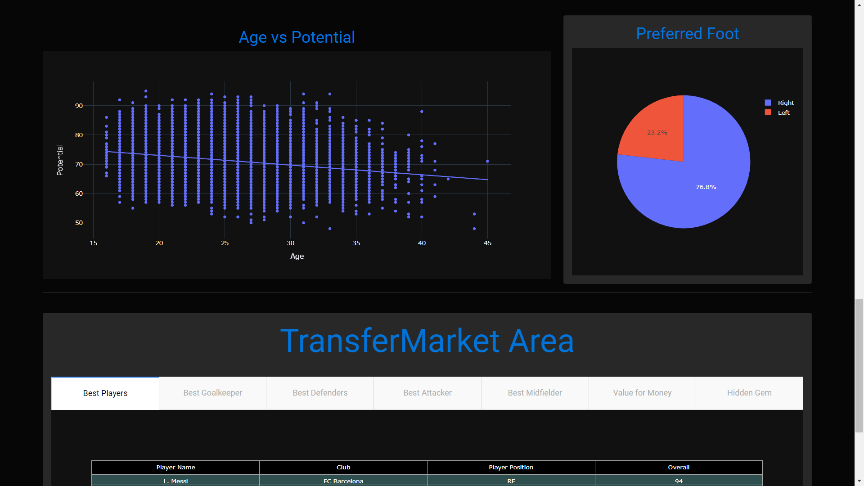

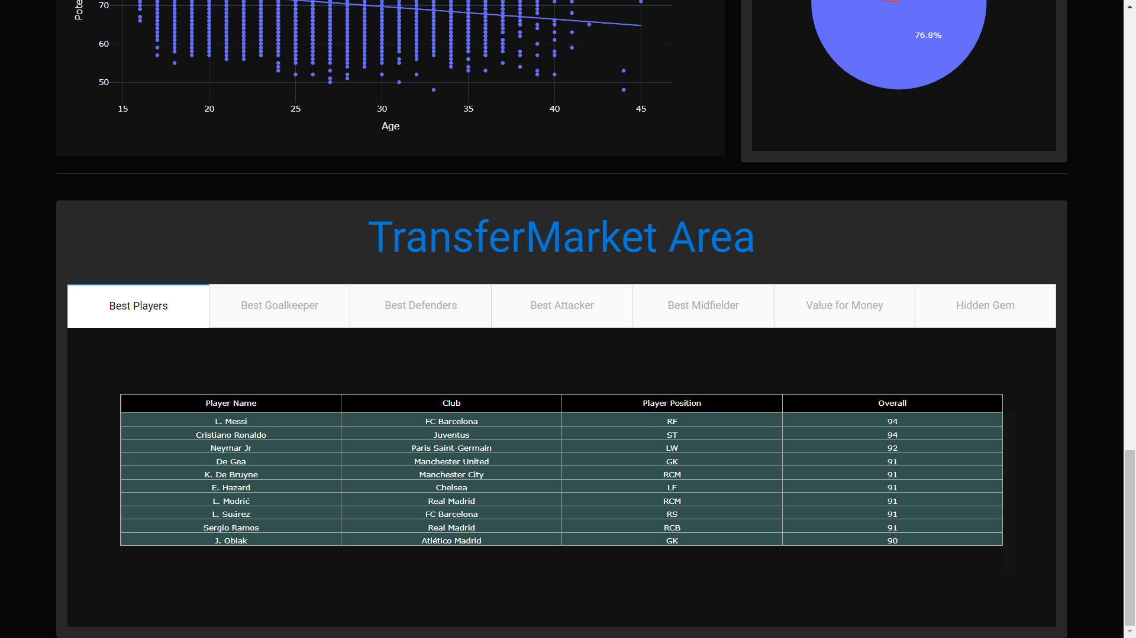

Explaining the Dashboard



This is the first row of the dashboard and is just the basic information of the data like the number of player, clubs, countries present in the data.

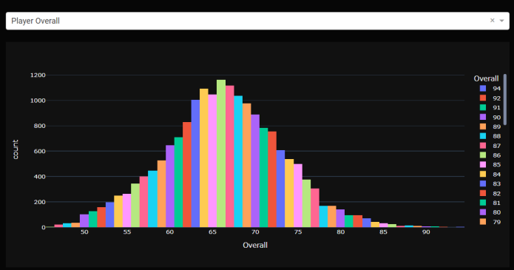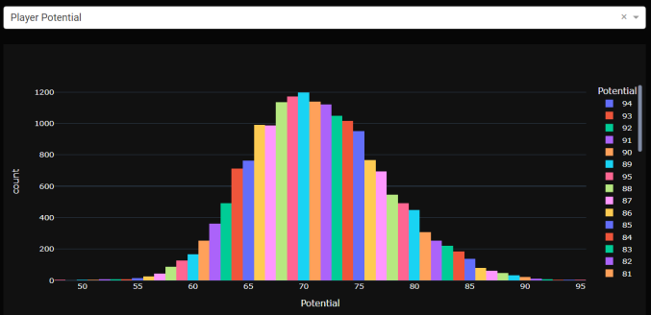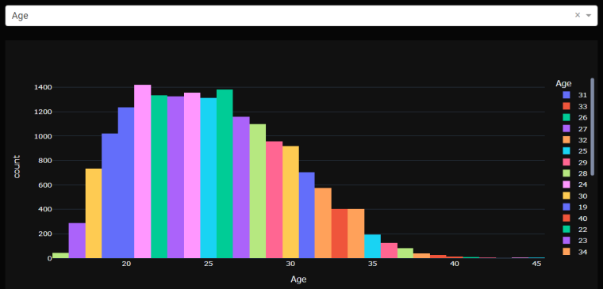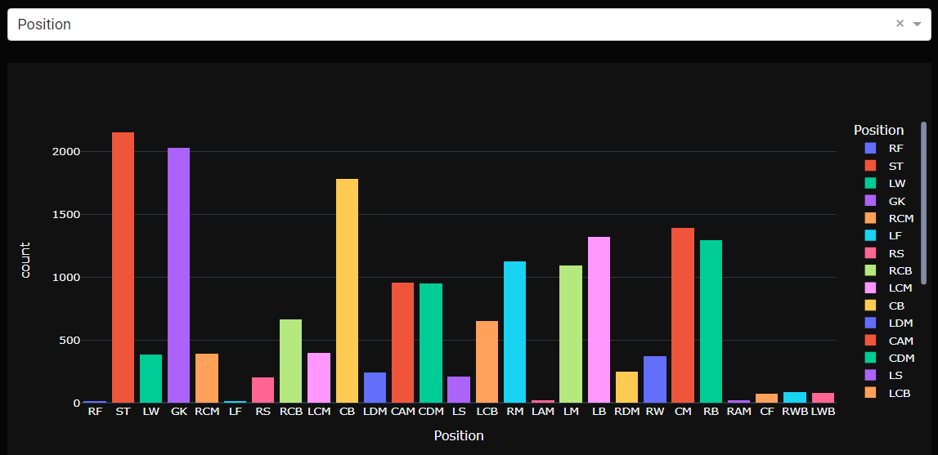

This is the part of the dashboard which represents the distribution of data in 4 different columns – Player Potential, Player Overall, Age, and Player Position respectively. It can be seen that Overall and Age is a normally distributed as most players are usually average and there are only a few professional players that are very bad or very good. But if we see the age histogram, we see that is positively skewed as when players tend to get older they and are unable to play they retire.

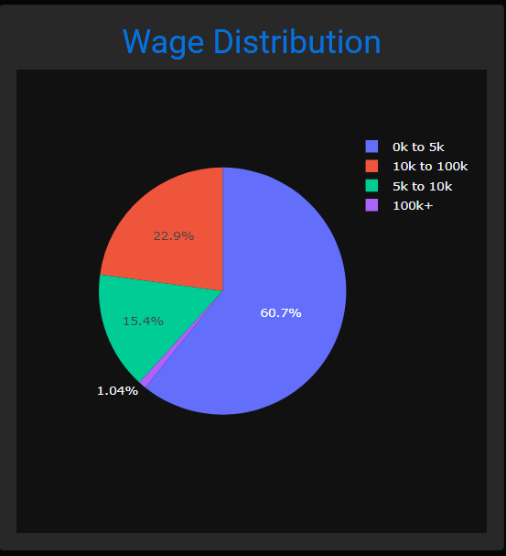

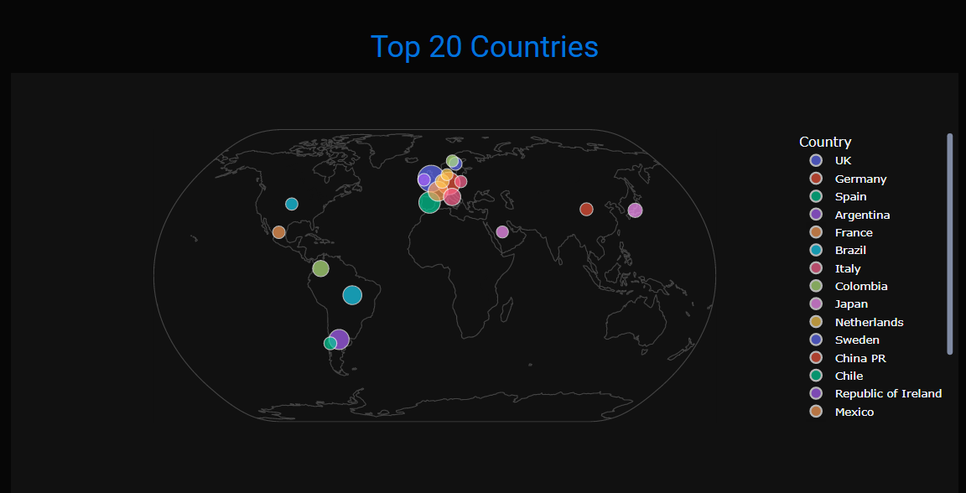The above is a Pie chart representing the player wage distribution. We can see that most of the players don’t receive that high a wage that we think football players receive. Only 1% of the players receive wages that exceed 100 thousand. Most receive wages between 1 and 10 thousand.

This is a geographic scatter plot representing the countries with the most FIFA players and their count. It can be seen that football is mostly popular in the continent of Europe where 11 of the 20 countries displayed lie.

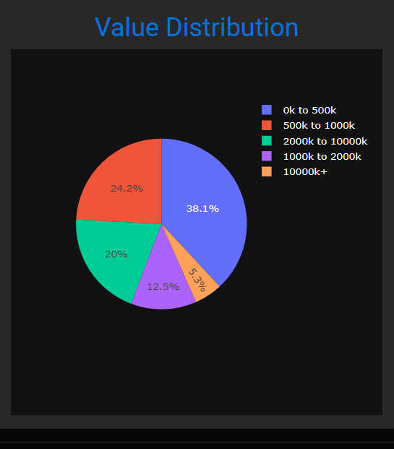

The above is a Pie chart representing the player Value distribution. We can see that only 5.3% of the players have a value within a million euros that, but only about 1% of the 5.3% of players are recognized by many.

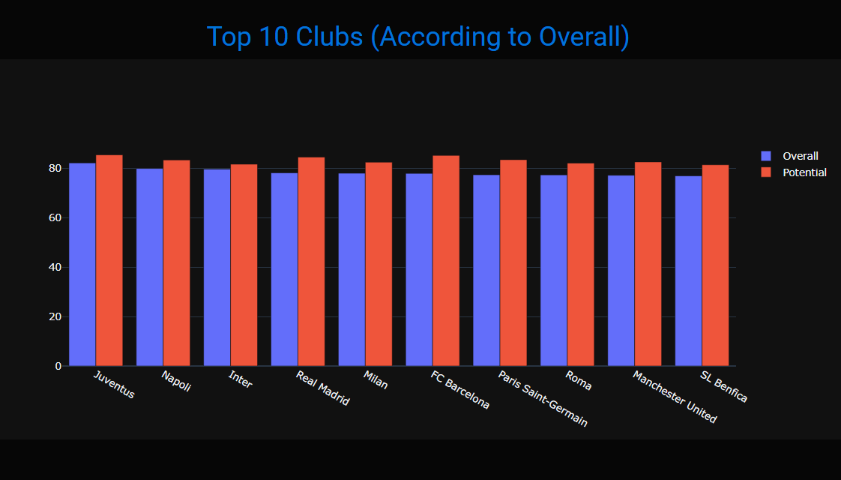

This is a bar chart of the top 10 teams according to the average overall of the players. The overall is plotted with the Potential which is the value of what the overall can be in the future. We can see that even though Barcelona have a lesser overall compared to Milan, Napoli, Inter and Real Madrid, their potential is greater than all of them.

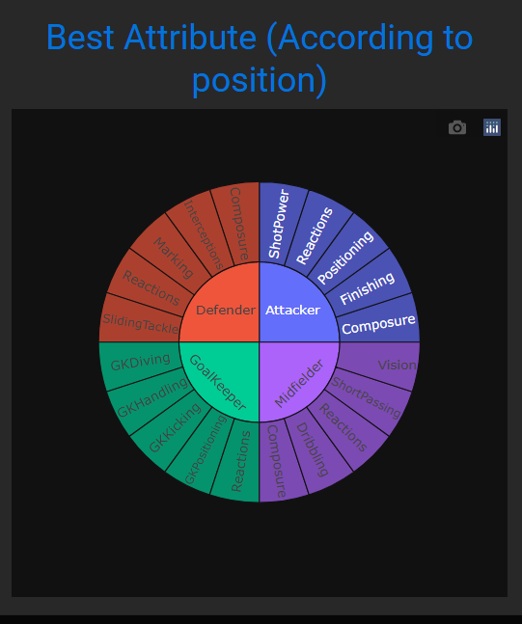

The above is a sunburst Chart of the representing what all attributes are the most important for each position. It was found by finding the highest correlation values with overall for each respective position.

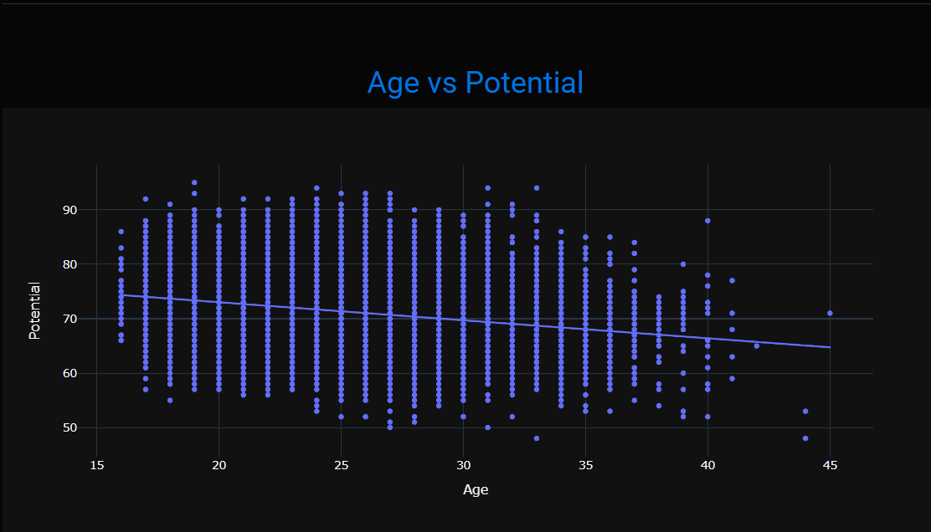

This is a scatter plot between the age and Potential in the dataset. The line tries to capture the essence of the scatter plot and has a negative slope. This seems to prove that Potential decreases with age which makes sense as the younger you are, you have more time to develop your skills and reach your potential, but as you get older your potential keeps decreasing.

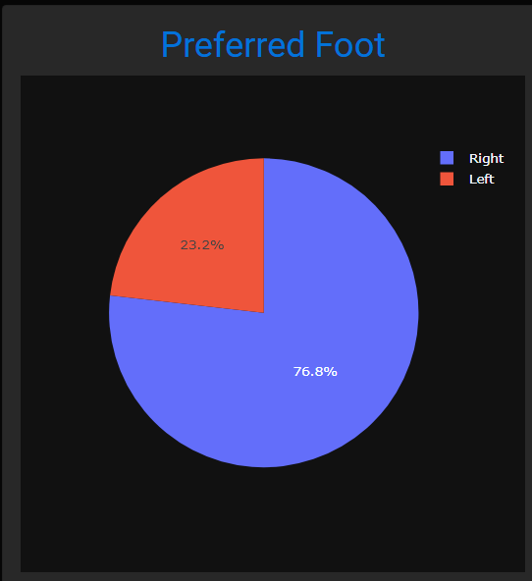

This is a pie chart representing the right footed and the left footed players in FIFA game. It can be seen that almost 77% of players in FIFA are right footed and left footed players are scarce. This is the reason why left footed players are actually payed more than the right footed players.

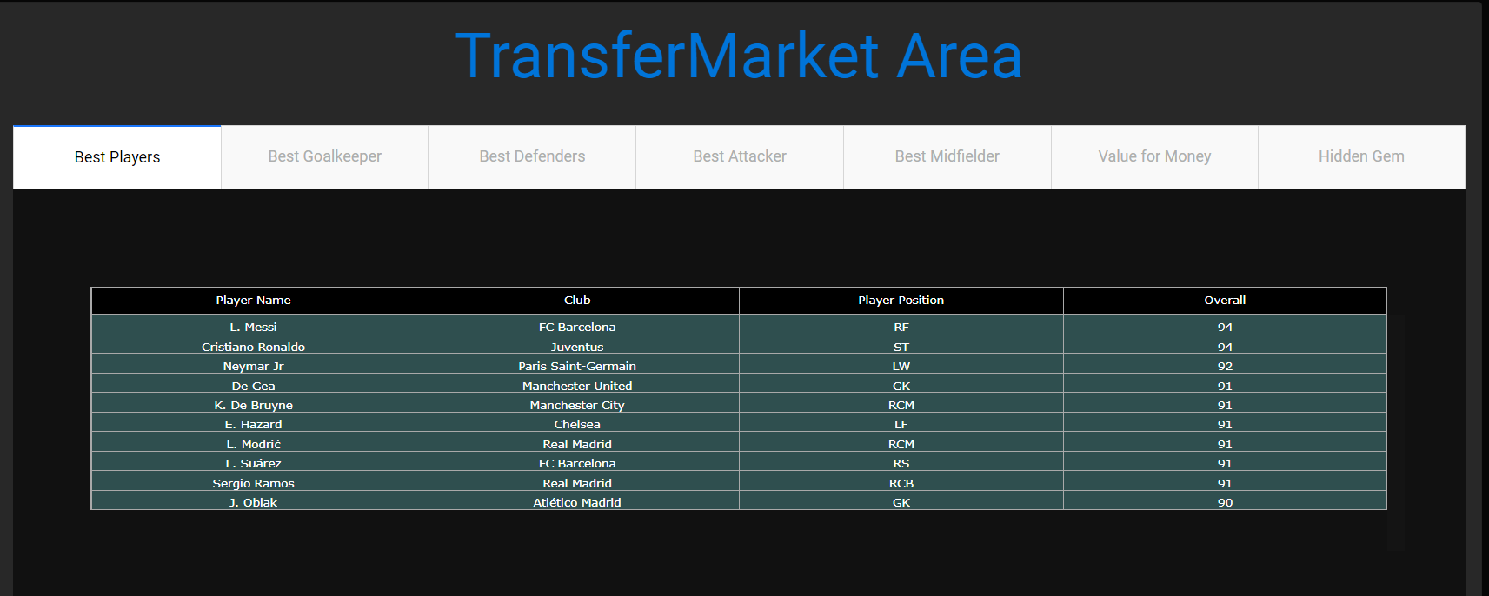

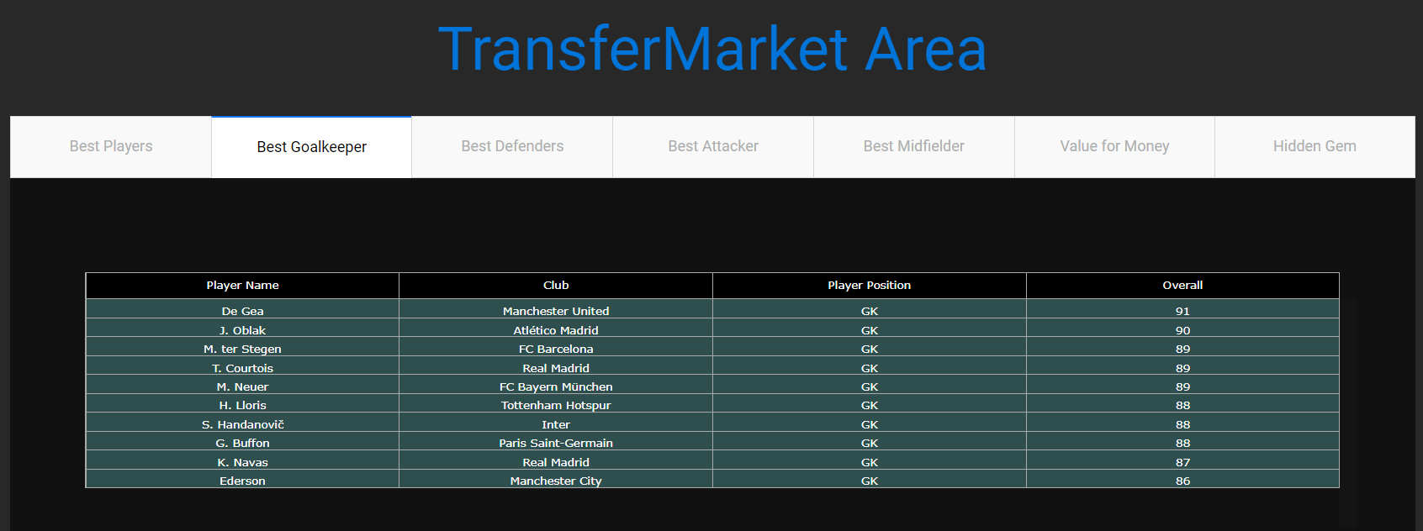

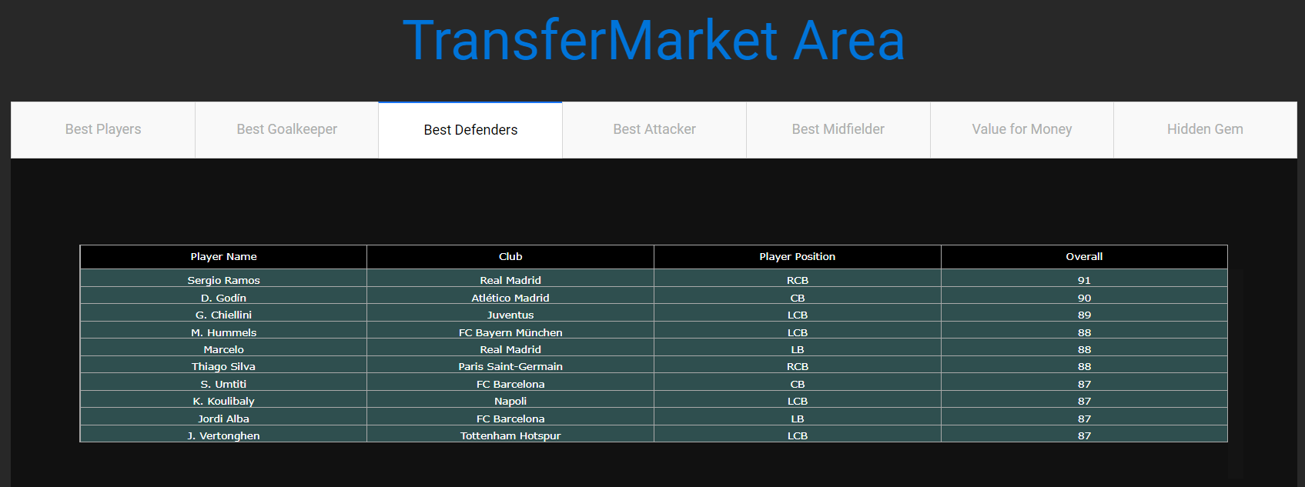

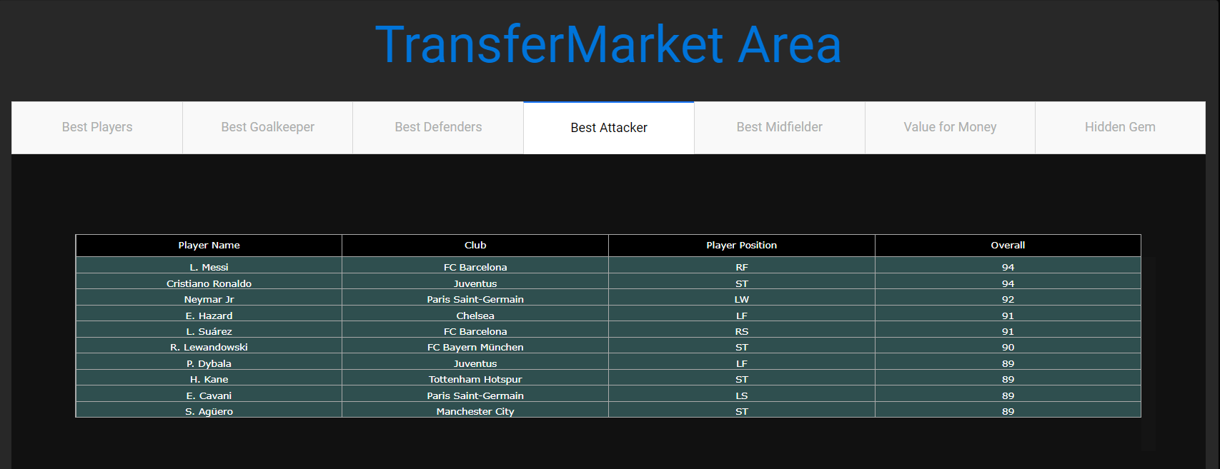

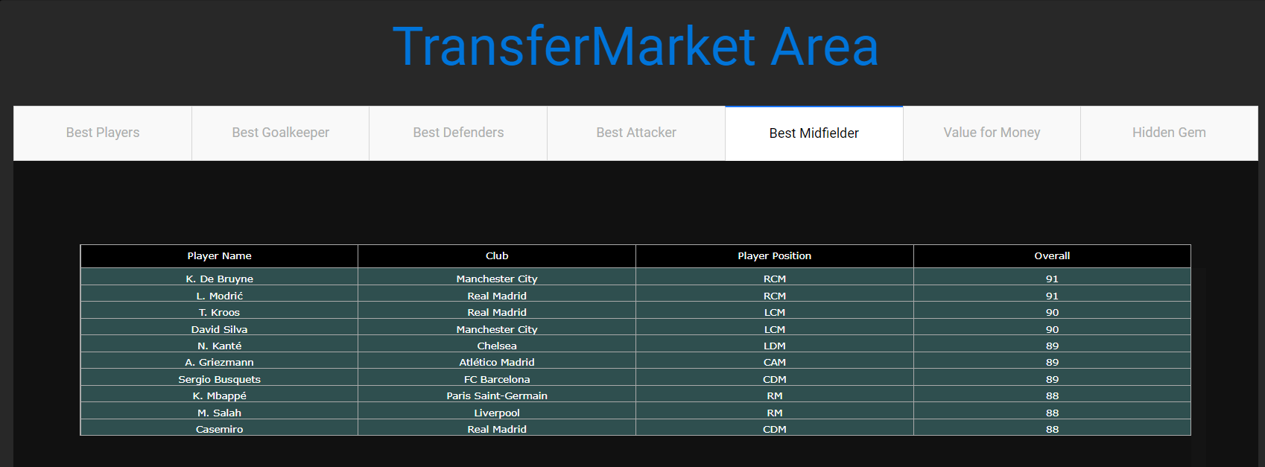

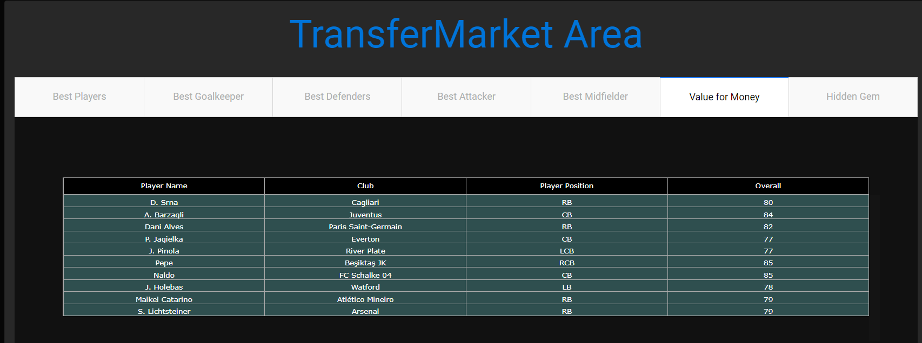

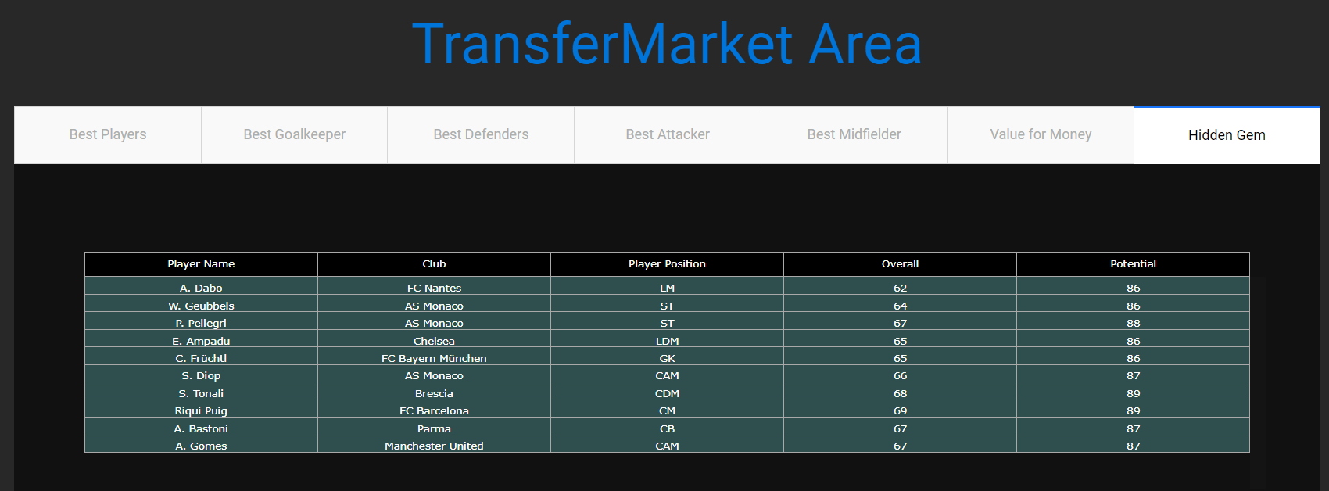

This is the Transfer market Area. Here we can see the best overall players or the best players for a particular position or the best value for money players or even the hidden gems who are players which are not so good at the moment but might become great in the future. The value for money tab gives us players which are available for a price lesser than they should be. We can see that most of these players are defenders which show that in these days defenders are usually not given the importance they deserve as most teams now are very attack minded.